AERO1005 MATLAB Coursework 2

Author: Sitan Wen
Student ID: 20719904
Date of report: 05/05/2026

For questions which require you to write text (i.e., descriptive sentences), or include images and graphs, please add them to the Word submission template.
Task 1
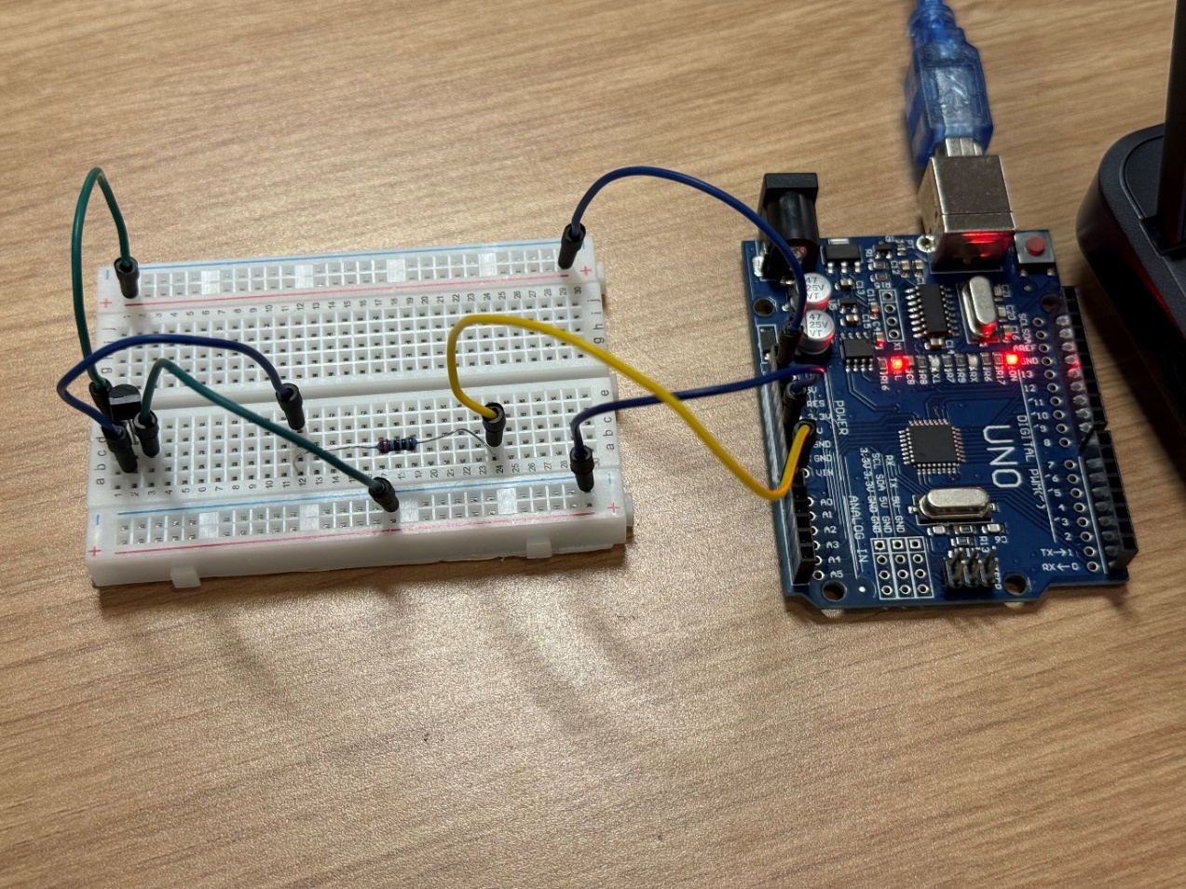
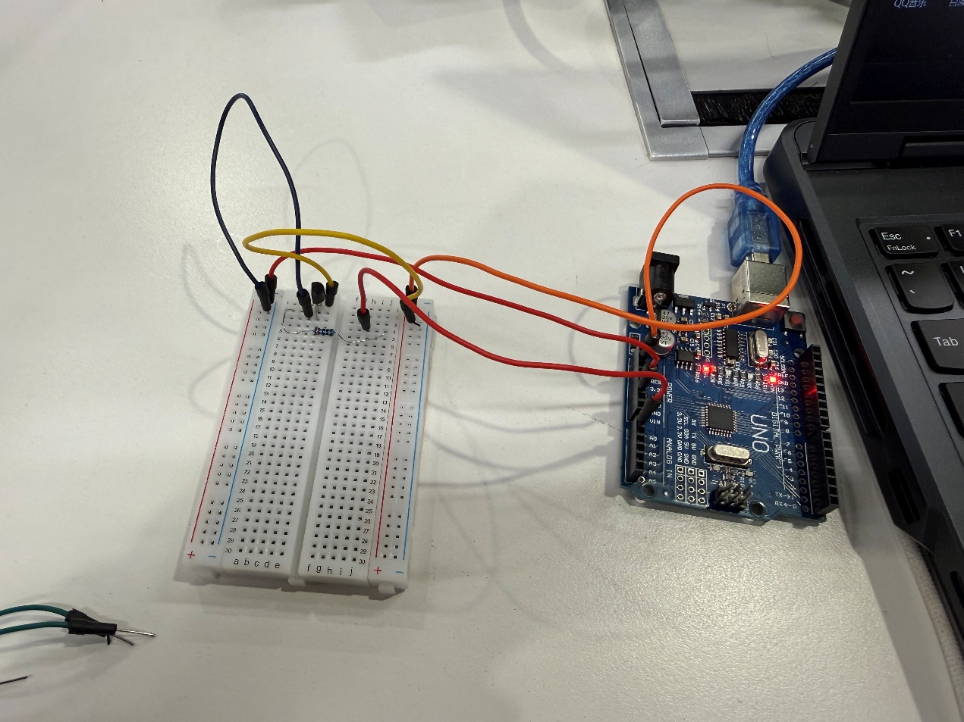
(d)
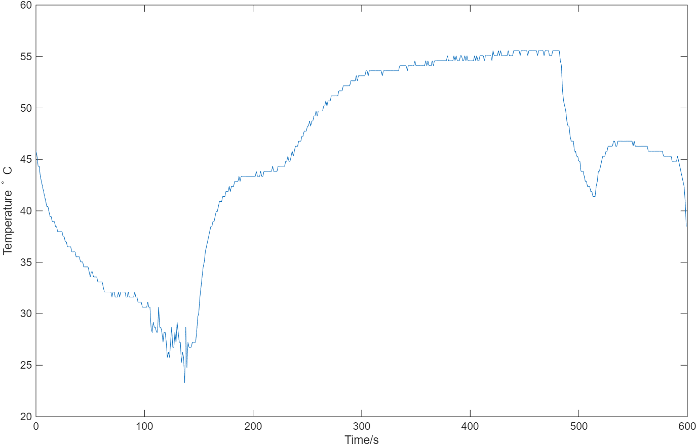

Task 2:
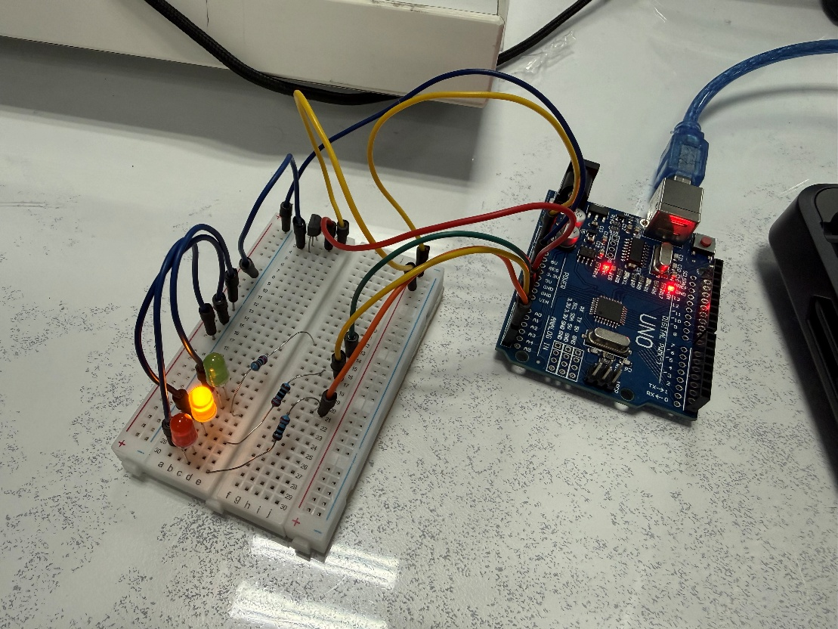

(g)flowchart
The first flowchart is for the first version. The second flowchart is for the second version.
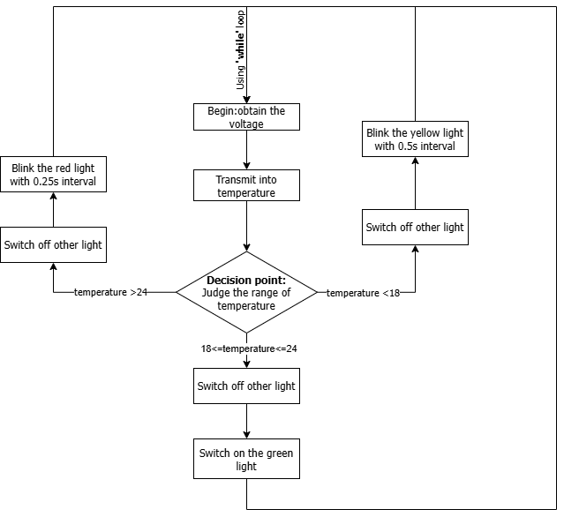
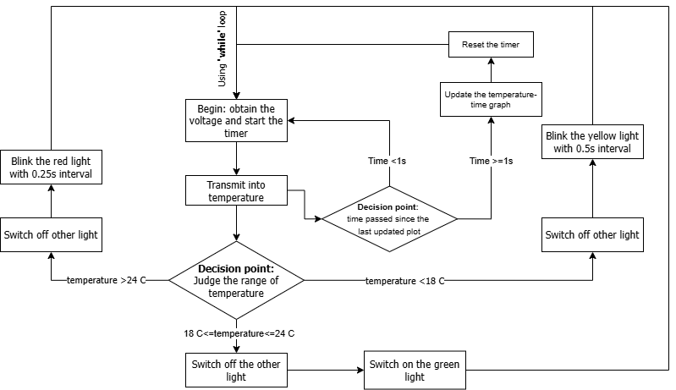

Task3
- This flowchart was finished before the task 3 code, which exists some difference with the true code in the Task 3 matlab part.
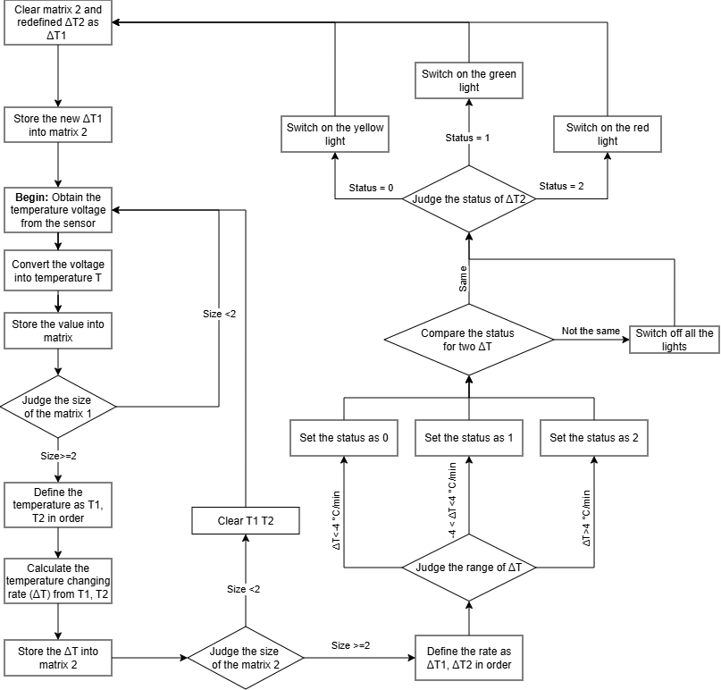
Task 4: reflective statement
In Coursework 2, the theoretical knowledge acquired in lectures was applied to a practical scenario for the first time. All assigned tasks were completed successfully. However, several challenges emerged during the coding process. One notable issue was the fluctuation in temperature readings observed while the program was running. Additionally, organising the wiring harnesses posed an initial difficulty, particularly in making the physical connections clearer and more systematic.
Understanding the underlying logic of the required code also presented a significant challenge before writing could commence. It was necessary to identify the most efficient, concise, and comprehensible approach and translate it into functional code. Fortunately, logical structuring proved to be a personal strength; the use of flowcharts enabled rapid development of the algorithmic framework. Nevertheless, translating these flowcharts into executable code introduced further difficulties. Certain logical sequences had to be modified during implementation, resulting in a final program that diverged from the original flowchart in several aspects.
After completing the program, some hardware-related issues became apparent. Specifically, in Task 3, it was observed that LED state transitions induced voltage fluctuations, which periodically distorted the temperature readings. Even under thermally stable conditions, the measured values oscillated beyond the classification threshold, causing spurious state toggling. Moreover, the steady illumination of an LED introduced a systematic offset in the measured temperature relative to the LED-off condition. Both effects are attributed to power-supply coupling inherent in the experimental hardware and are not indicative of algorithmic deficiencies.
For future improvements, it is recommended that more precise instrumentation be employed, or that appropriate capacitance be added to the circuit to stabilize the supply voltage and mitigate these coupling effects.

